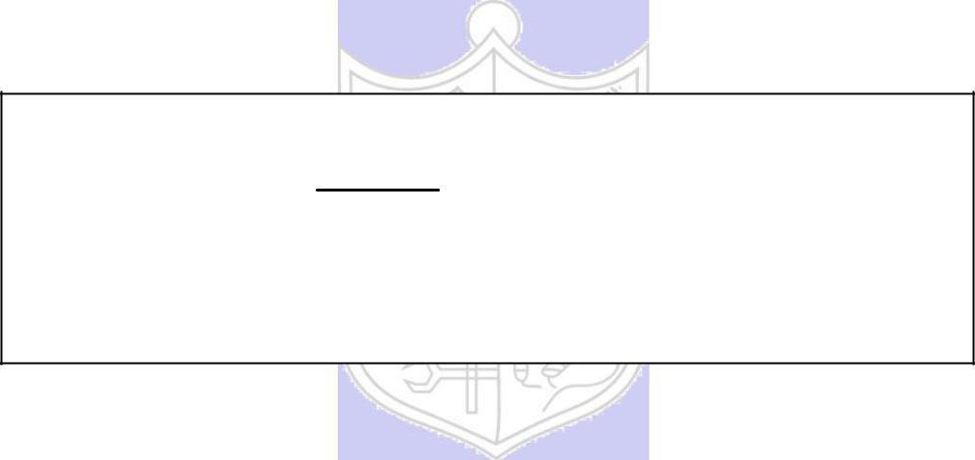

**Experiment No. 2**

**Title: Transposition Cipher**

**Batch:** **Roll No.:** **Experiment No.:**

**Aim:** To implement transposition cipher – Row transposition and column transposition cipher.

**Resources needed:** Windows/Linux

**Theory**

**Pre Lab/ Prior Concepts:**

**Symmetric-key algorithms** are a class [of algorithms for cryptography that](http://en.wikipedia.org/wiki/Algorithm) use the same cryptographic keys for both encryption of plaintext and decryption of cipher text. The keys may be identical or there may be a simple transformation to go between the two keys. The keys, in practice, represent a shared secret between two or more parties that can be used to maintain a private information link. This requirement that both parties have access to the secret key is one of the main drawbacks of symmetric key encryption, in comparison to public-key encryption. Symmetric-key encryption can use either stream ciphers or block ciphers. Transposition Cipher is block cipher. Ancient cryptographic systems are classified as: Substitution and Permutation/Transposition Ciphers.

**Transposition Cipher/Permutation Cipher**

A transposition cipher rearranges (permutes) symbols in a block without altering actual values. It has the same frequency distribution as the original text .So it is easily recognizable.

EXAMPLE :

Plaintext: HELLO MY DEAR

Cipher text: ELHLMDOYAER

There are varieties of transposition ciphers like: keyless and keyed transposition ciphers.

Following figure shows the combination of both keyed and keyless. To encrypt with a transposition cipher, we first write the plaintext into a matrix of a given size and then permute the rows or columns according to specified permutations.

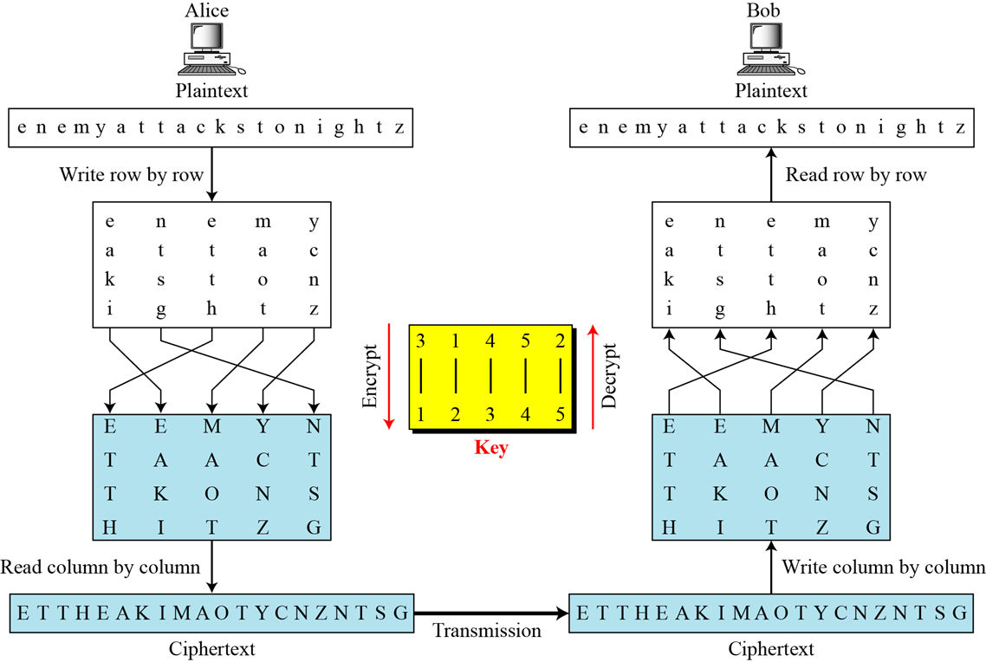

For the transposition, the key consists of the size of the matrix and the row or column permutations. The recipient who knows the key can simply put the cipher text into the appropriate sized matrix and undo the permutations to recover the plaintext.

Unlike a simple substitution, the transposition does nothing to disguise the letters that appear in the message But it does appear to thwart an attack that relies on the statistical information contained in the plaintext, since the plaintext statistics are disbursed throughout the cipher text. The double transposition is not a trivial cipher to break.

**___________________________________________________________________________**

**Activity :**

**Implement**

1. **Row transposition cipher**
2. **Column transposition cipher**
3. **Double transposition cipher (row followed by column)**

**___________________________________________________________________________**

**Implementation:**

The program should have encryption function and decryption function for each cipher. Function should take message and a key as input from the user and display the expected output.

**___________________________________________________________________________**

**Results:** (Program with output as per the format)

**___________________________________________________________________________**

**Questions:**

1. Compare substitution ciphers and transposition/permutation ciphers.
2. Define confusion and diffusion properties. Comment on of both substitution and transposition ciphers w.r.t. confusion and diffusion properties.



**Outcomes:**

**Conclusion:**

**Grade: AA / AB / BB / BC / CC / CD /DD**

**Signature of faculty in-charge with date**

**References: Books/ Journals/ Websites:**

1. Behrouz A. Forouzan, “Cryptography and Network Security”, Tata McGraw Hill
2. Mark Stamp, “Information Security Principles and Practice”, Wiley.
3. William Stalling, “Cryptography and Network Security”, Prentice Hall